#### INTELLIGENT SAFETY SYSTEM

A Case Study Report

Submitted in partial fulfillment of the Requirements for the Course of

**Theme-based project**

IN

**BE ¾ (IT) II-SEMESTER**

By

**P Naresh Kumar**

**1602-16-737-025**

**Y Apuroop**

**1602-16-737-008**

**Mehraj Sultana**

**1602-16-737-024**



**Department of Information Technology**

**Vasavi College of Engineering (Autonomous)**

**Ibrahimbagh, Hyderabad-31**

**2018-19**

**Vasavi College of Engineering (Autonomous)**

**Ibrahimbagh, Hyderabad-31**

**Department of Information Technology**



**DECLARATION BY THE CANDIDATES**

We, **P.Naresh Kumar, Y.Apuroop, Mehraj Sultana** bearing hall ticket numbes, **1602-16-737-025, 1602-16-737-008, 1602-16-737-024** respectively, hereby declare that the Case study report entitled **“INTELLIGENT SAFETY SYSTEM”** under the guidance of **Mrs J.SUNEETHA ,** Assistant Professor, Department of Information Technology, VCE, Hyderabad is submitted in partial fulfillment of the requirement for the course of **Theme Based Project - Lab** in BE ¾ (IT) II-Semester.

This is a record of Bonafide work carried out by us and the Design embodied in this project report has not been submitted by any others.

1. **Naresh Kumar**

**1602-16-737-025**

1. **Apuroop**

**1602-16-737-008**

**Mehraj 1602-16-737-024**

**Vasavi College of Engineering (Autonomous)**

**Ibrahimbagh, Hyderabad-31**

**Department of Information Technology**



**BONAFIDE CERTIFICATE**

This is to certify that the project entitled **“INTELLIGENT SAFETY SYSTEM”** being submitted by **P.Naresh Kumar, Y.Apuroop, Mehraj Sultana** bearing hall ticket numbers **1602-16-737-025, 1602-16-737-008, 1602-16-737-024,** in partial fulfillment of the requirement for the course of **Theme Based Project- Lab** in BE ¾ (IT) II-Semester is a record of bonafide work carried out by him/her under my guidance.

**Mrs. J SUNEETHA, Dr.K.Ram Mohan Rao,**

**Assistant professor, Professor and HOD,**

**Internal Guide. Department of IT.**

**External Examiner.**

**ACKNOWLEDGEMENT**

We take this opportunity with pride and enormous gratitude, to express the deeply embedded feeling and gratefulness to our respectable guide Mrs J SUNEETHA, Department of Information Technology. Whose guidance was unforgettable and innovative ideas as well as her constructive suggestions has made the presentation of our project a grand success.

We are thankful to Dr. K Ram Mohan Rao,Head of Department (IT), Vasavi College of Engineering for their help during our course work.

Finally at last but not least express our heart full thanks to the management of our college, Vasavi College of Engineering for providing the necessary arrangements and support to complete our seminar work successively.

P Naresh Kumar 1602-16-737-025

Y Apuroop

1602-16-737-008

Mehraj Sultana

1602-16-737-024

**TABLE OF CONTENTS**

1.Abstract------------------------------------------------------06

2.Introduction--------------------------------------------------07

I. Requirements--------------------------09

3.Related Work------------------------------------------------------10

4.Proposed Work---------------------------------------------------12

1. Use Cases------------------------------12
2. UI Prototypes And Screenshots----------13
3. Architecture And Technology Used-----15
4. UML Design-------------------------------17
5. Implementation-------------------21
6. Testing----------------------------24

6. Results -----------------24

7. Discussion And Future Work --------------25

8. References---------------------26

**ABSTRACT**

Here we introduce an app which ensures the safety of people in emergency. This helps to identify and call on resources to help the one out of dangerous situations. This reduces risk and brings assistance when we need it and help us to identify the location of the one in danger.

The best way to minimize your changes of becoming a victim to accidents, robber etc. is to identify and call on resources to you out of dangerous situations. Whether you are in immediate trouble or get separated from friends during night out and don't know to get home , having such an app on your phone can reduce risk.

This app contains features like sending a default message, making a phone call and sharing live location.

**INTRODUCTION**

Intelligent Safety System is an application which is developed to help women, this intelligent system is also for every individual.

Safety of the women matters a lot at home, outside the home or working place. According to the statistics, highest rate of crime was recorded in Chennai in 2018(around 4,037 incidents).

3,27,394 cases registered of against women in a year in India.

Delhi contributed to 52% of all the crimes against women in India in a year.

This android application provide security to Women at Emergency Situations propose the security on a single click of a single button for the women travelling at night or alone. No need to unlock the screen, instead by just pressing the power button it directly triggers the application to run at the background, to send the emergency message including the location in the form of latitude and longitude to the registered contacts.

There is one death every four minutes due to road accidents in India.

Robberies and Accidents became common in India and for such situations this application is really useful for the individual

This application has a option of directly sending the live location to the person we want to send without just telling the exact location of the person, it saves the time.

**REQUIREMENTS:**

**Data Base Management:**

* Control the data and keep track of all records of phone numbers of that person chooses.

**Performance Requirements:**

* System sends the accurate location to users.
* System sends messages and locations to users very quickly.

**Safety Requirements:**

* System shall not cause any harm to human users.

**Security Requirements:**

* User can modify data any time they want and that data cannot be manipulated by anyone other than the user itself.

**RELATED WORKS**

**IMPROVEMENTS:**

* Our approach is quite similar to the existing safety applications. The only difference is that we plan to provide a feature for the users where they can share their location by shaking the phone twice.
* They can send emergency messages by using hardware buttons like volume buttons. They can make calls using volume buttons.

**Limitations:**

* In this Application Volume Button and Shaking Feature only works when the app is open.
* This Application can store only three specified numbers not more than that,the top 3 priority numbers are stored.

**PROPOSED WORK**

1. USE CASE.

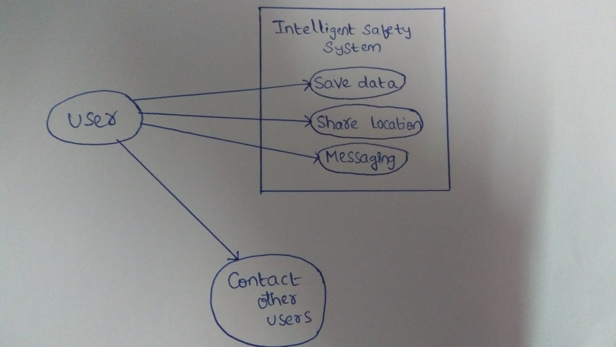

Use case is a software and system engineering term that describes how user uses a system to accomplish a particular goal. A view describes the functionality of the system as perceived by an external actor. An actor interacts with the system;it can be a user or another system. The use case view is for customers,designers,developers and testers. The functions of the systems are described as a number of use cases in the use case view. The systems for some functions are represented by use cases.

The Three basic elements that make up a use case are:

ACTORS:

Type of users interacting with the systems. Here individuals are actors.

SYSTEM:

Functional Requirements that specify the intended behaviour of the system.

GOAL:

Use cases are typically intended to fulfill the goals. Here creating an interacting environment for individuals.

2.UI PROTOTYPES.

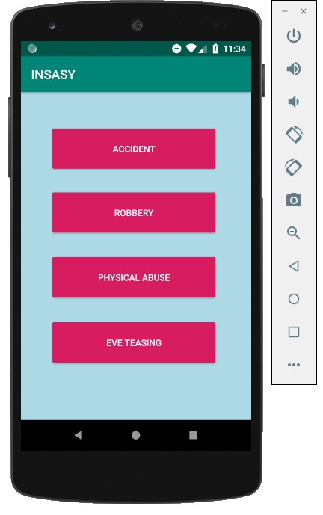

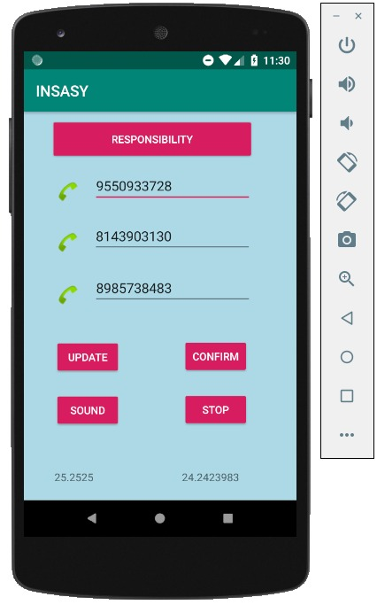

3.ARCHITECTURE AND TECHNOLOGY USED.

This Project is implemented using ANDROID STUDIO.

FRAMEWORKS USED ARE:

**FRONT END**

* XML(Extensible Markup Language)

**BACK END**

* JAVA

**DESIGN**

UML Static Diagrams: Data Flow Diagram Level-I

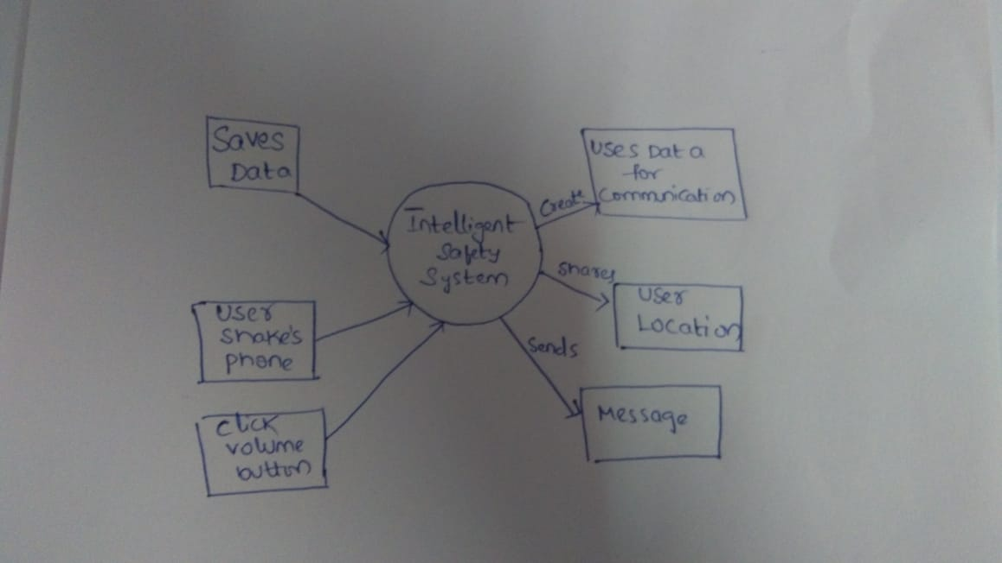

**UML Run Time Diagram**

Sequence Flow

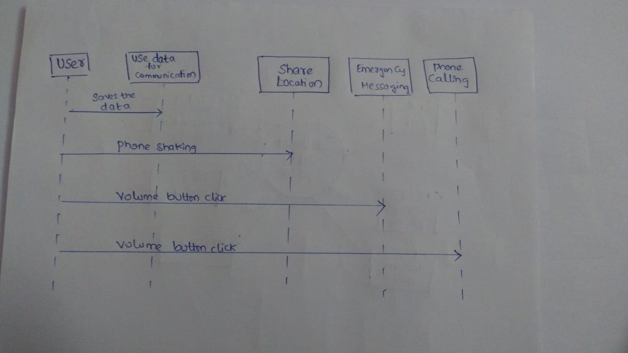

**USER OPERATION MODULE**

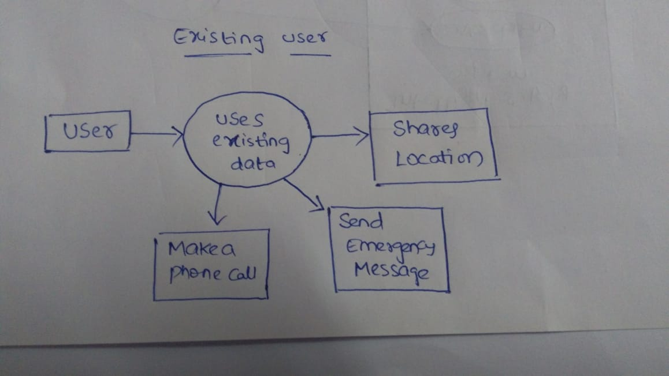

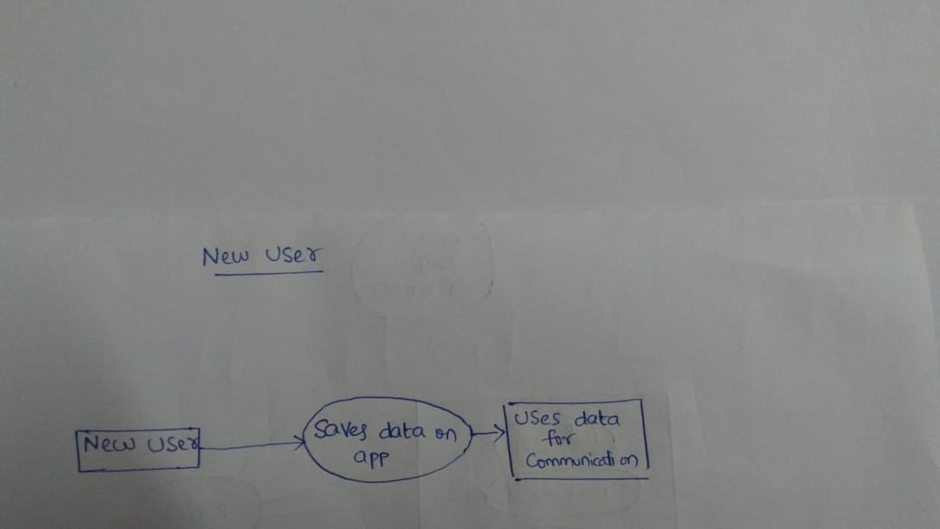

**IMPLEMENTATION**

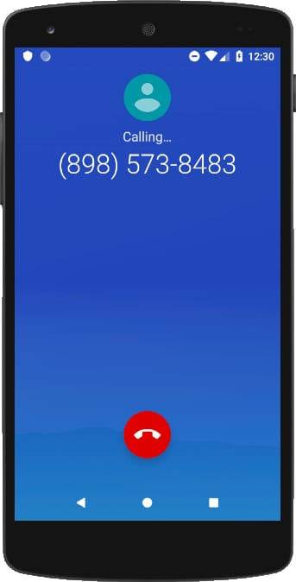

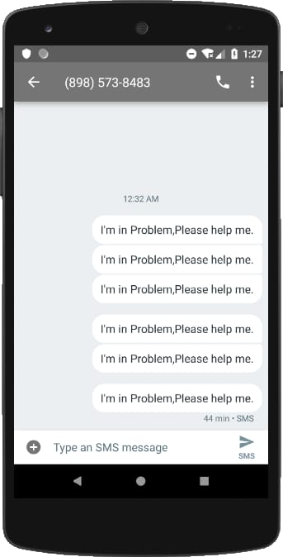

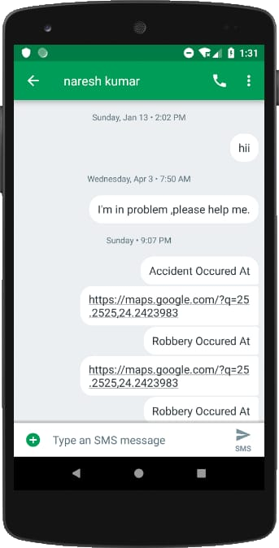

**TESTING**

Checks the permissions of included services if not found, displays an error message.

System only allows user to enter digits only, Characters are not allowed.

It performs the necessary action only when the phone is shaken at a certain threshold limit.

**RESULTS**

* Our approach is quite similar to the existing safety applications. The only difference is that we plan to provide a feature for the users where they can share their location by shaking the phone twice.
* They can send emergency messages by using hardware buttons like volume buttons. They can make calls using volume buttons.

**DISCUSSIONS AND FUTURE WORK**

We will be implement the already existing features to work even when the phone screen is off.

We will add the feature of recording audio and sending it to the number stored.

We will add the feature of live streaming on any of your social media.

**REFERENCES**

1.Android Developers - <https://developer.android.com/>

2. Workshop on Android Studio

3. Location Services - <https://developer.android.com/s/results/?q=fusedlocationproviderclient>